Packages to be known for Machine learning

1. Numpy
2. Pandas
3. Scipy
4. Scikit-learn
5. Matplotlib
6. Seaborn

Scikit-learn :

* Lots of machine learning libraries.
* In built classification, Regression and clustering algorithms
* Build with flexibility to use Numpy and Scipy which helps easy to play with data.
* Most preprocessing tasks are inbuilt in scikit-learn such as Data preprocessing, Future Selection, extraction and train – test splitting, algorithm, prediction, evaluation and exploring the model.

**Supervised vs Unsupervised learning:**

**Supervised learning:**

Train the model with labelled dataset.

1. Classification – process of predicting discrete class label or category.

Eg. Predicting the class such as finding the cancer in cells of human, customer churn in telecom.

1. Regression – process of predicting a continuous value.

Eg. Predicting the house price, stock price.

**Unsupervised learning:**

We do not supervise the model, but the model trains on its own and discover information that are invisible to human eye.

1. Dimension reduction – reducing the redundant future to make classification easier.
2. Density estimation – explore data to find substructure
3. Market basket analysis or Association – based on theory of if a customer buys certain product, then he is likely to buy another product as well.
4. Clustering – grouping of data points that are similar somehow. Eg. Segment customer based on credit score in banking. Used for Discovering structure, summarization and Anomaly detection.

**Few more Machine learning techniques:**

Anomaly detection – discovering abnormal cases eg. Credit card fraud detection

Sequence mining – predict the next occurrence eg. Click stream

Recommender systems – Recommending items eg Netflix, youtube.

**Clustering:**

* Customer segmentation to group customer based on specific category so that the market can focus on specific group.
* Clustering is the best approach to group data only unsupervised. (Group the object that are similar to other object and dissimilar to data points in another cluster).
* Its partition each group into a mutually exclusive cluster.

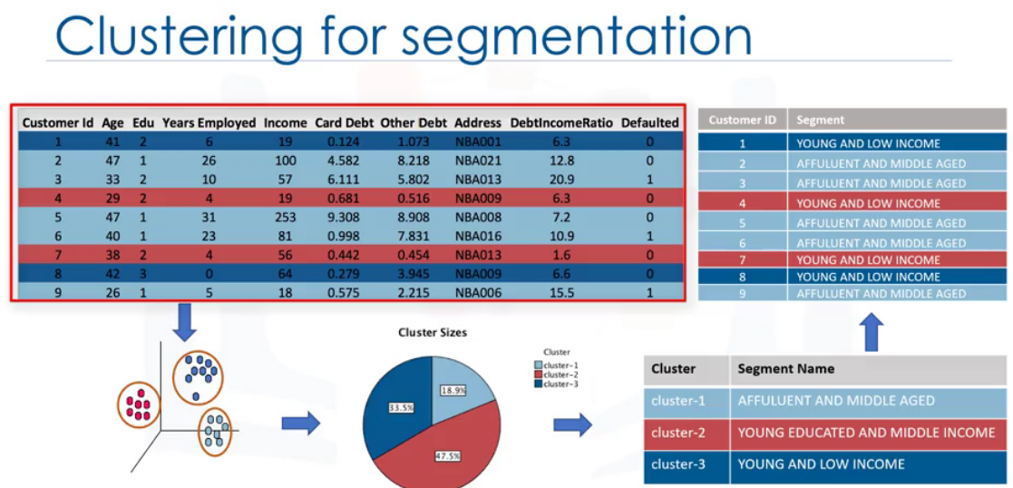

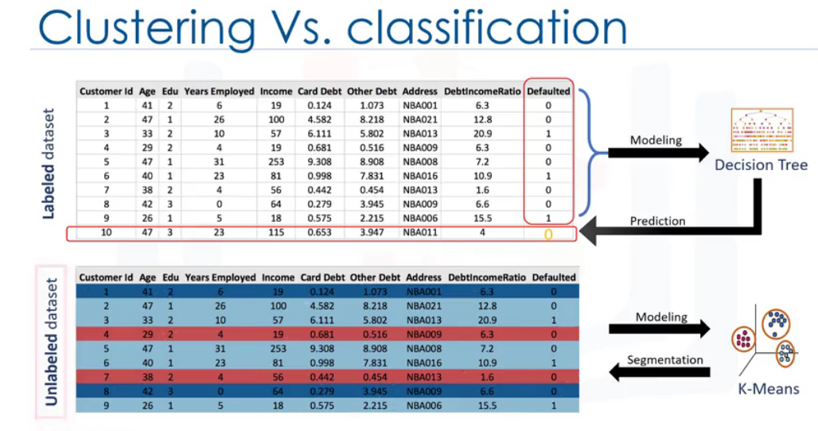

**Applications of Clustering:**

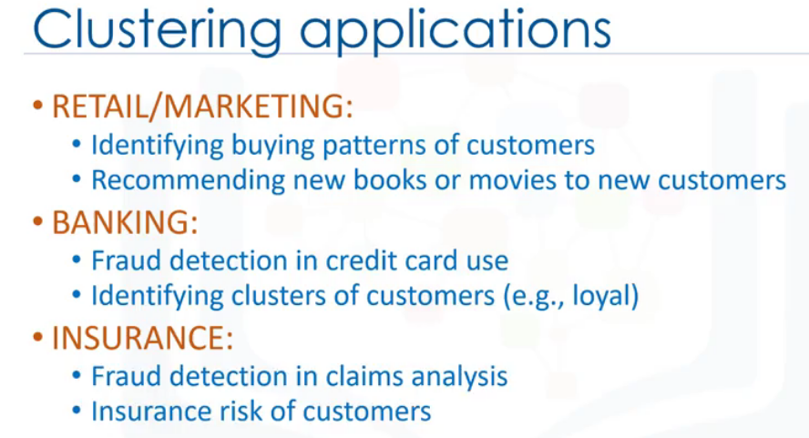

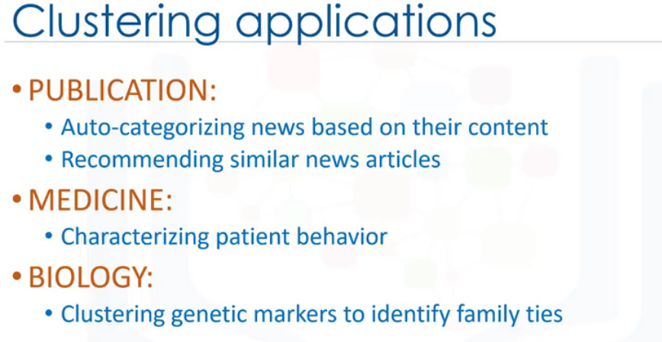

**Why to use Clustering:**

* Exploring data analysis
* Summary generation
* Outlier detection
* Finding duplicates, Data preprocessing.

**Types of Clustering:**

Partition based Clustering:

* Used for medium or large volume of data set. Relatively efficient.
* Eg. K-means, K-median , Fuzzy c-Means.

Hierarchical Clustering:

* Used in very less volume of data set.
* Produce trees of cluster.
* Eg. Agglomerative, Divisive

Density based clustering:

* Produce arbitrary based cluster. Good dealing with spatial data set and noisy data set.
* Eg DB scan

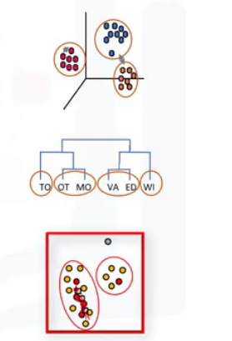

**K- Means Clustering:**

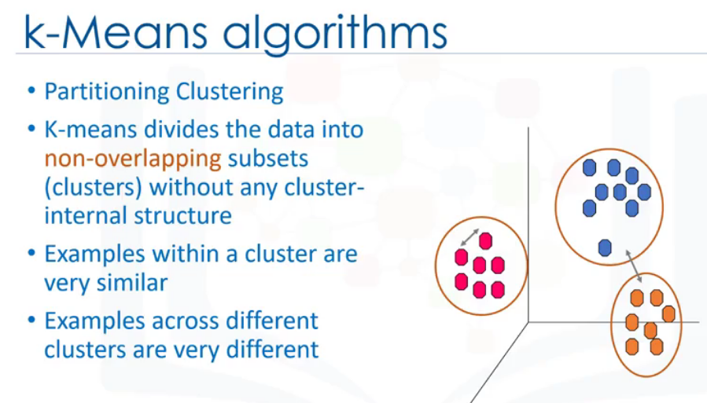

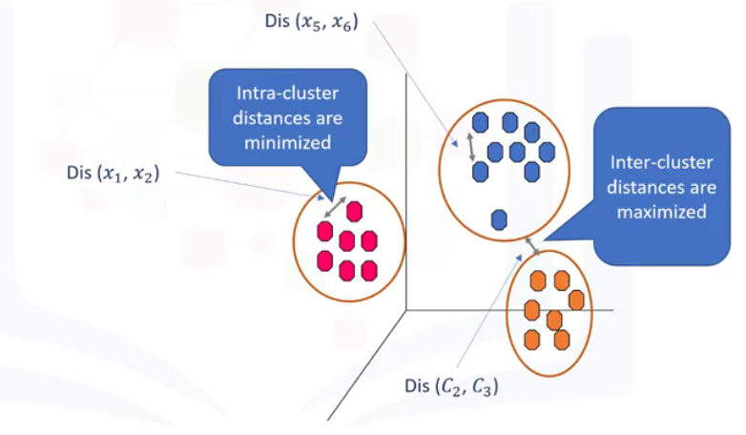

Calculate the distance using Euclidian distance formula. Here Euclidian distance is used based on the domain.

Algorithm:

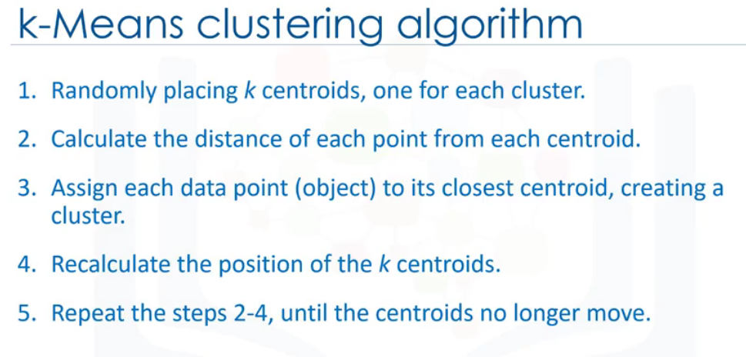

**Choosing the centroid randomly causes very high error.**

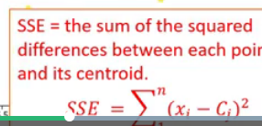

Repeat step 2 to 4 until the algorithm converges. It is a heuristic algorithm, there is no global optimum. It may result in local optimum. To resolve the problem, we must run the algorithm multiple times.

**K- means accuracy:**

**Internal Approach:** Average the distance between the datapoints in the cluster.

**Choosing K:**

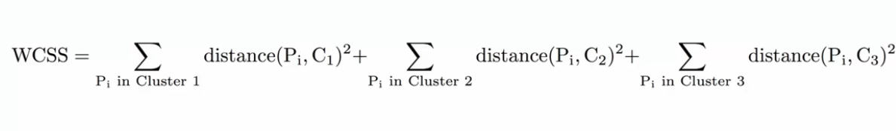

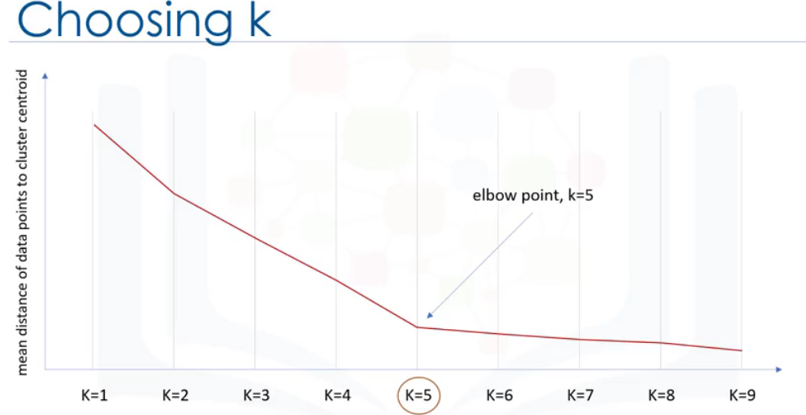

To find optimal K value, iterate until you find a huge drop. In the above K=5 will be the optimal value.

**Packages:**

import random

import numpy as np

import matplotlib.pyplot as plt

from sklearn.cluster import KMeans

from sklearn.datasets.samples_generator import make_blobs

**Hierarchical clustering:**

Builds hierarchy of clusters where each node is a cluster consisting of clusters of its daughter node.

Two types of strategy:

Divisive – top down approach

**Agglomerative** (Collect things) - bottom up approach (each cluster is started and pairs of clusters are combined as we move up the hierarchy.

It moves up the ladder by progressively merging cluster.

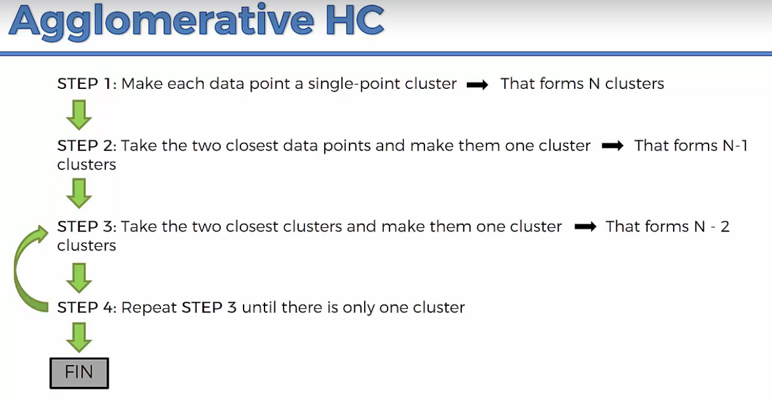

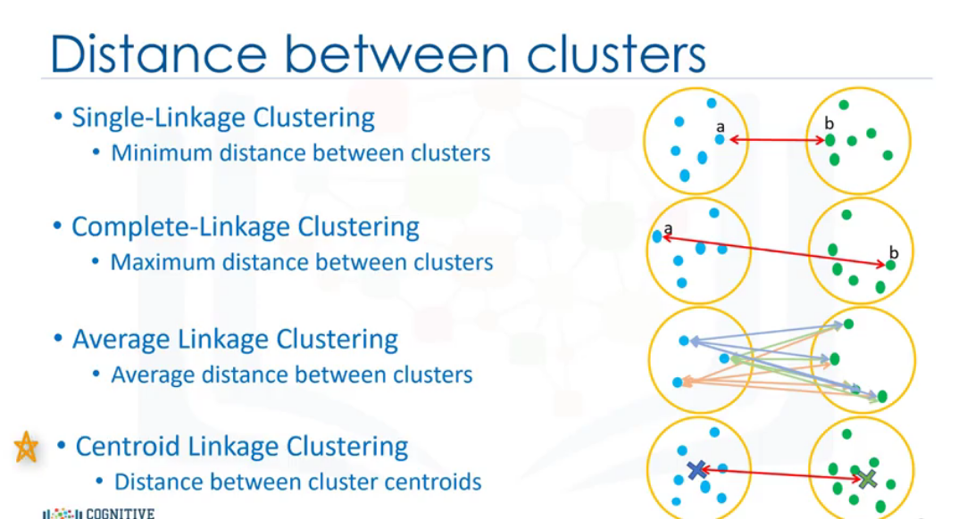

Use dendrogram approach to proceed further to do hierarchical closeting. Dendrogram is the memory of HC algorithm.

Start forming cluster for the points that are closest. Calculate the distance between them using Euclidean distance which shows the dissimilarity between the two points in the cluster.

Height of the bar in the dendrogram is based on dissimilarity between them.

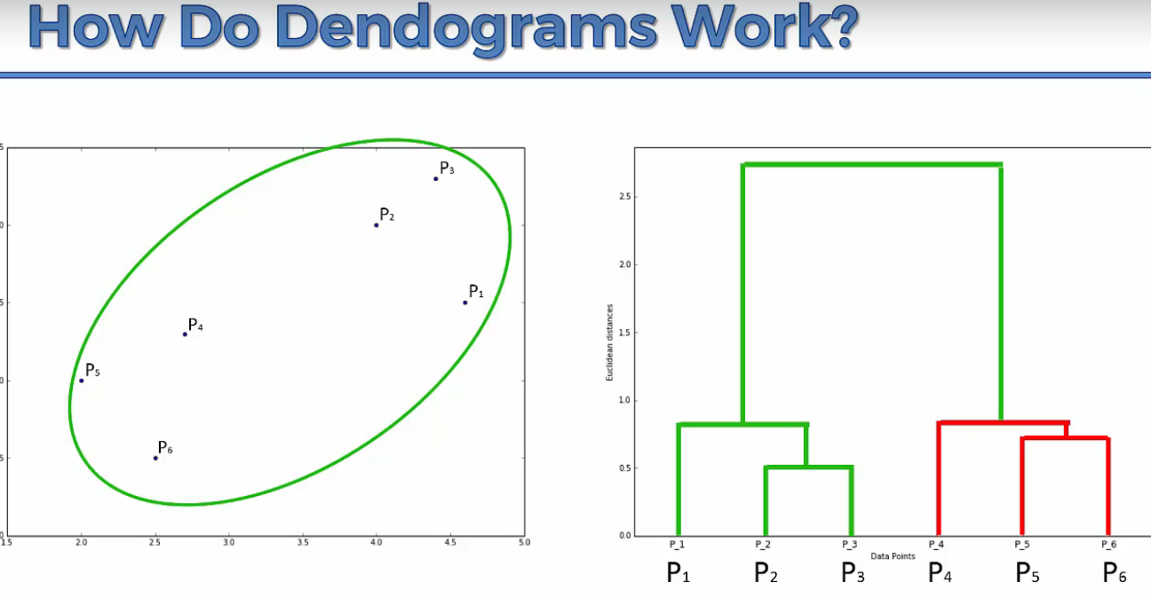

Next step is setting threshold so that there will two clusters differentiated by the threshold.

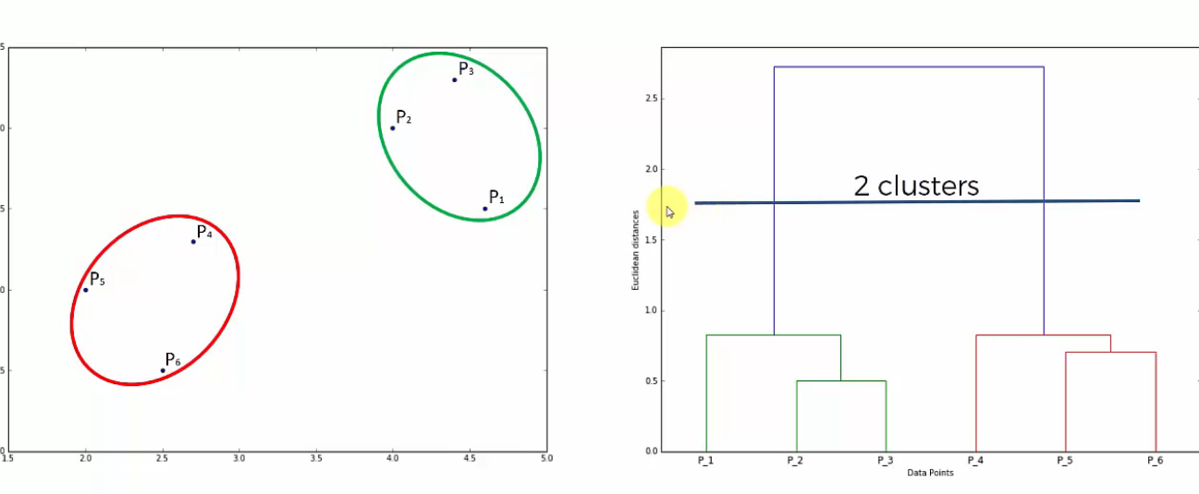

How to find the optima number of clusters:

Find the largest distance which doesn’t cut the horizontal line. That will determine your number of clusters. To set the threshold, find the center point of the largest distance.

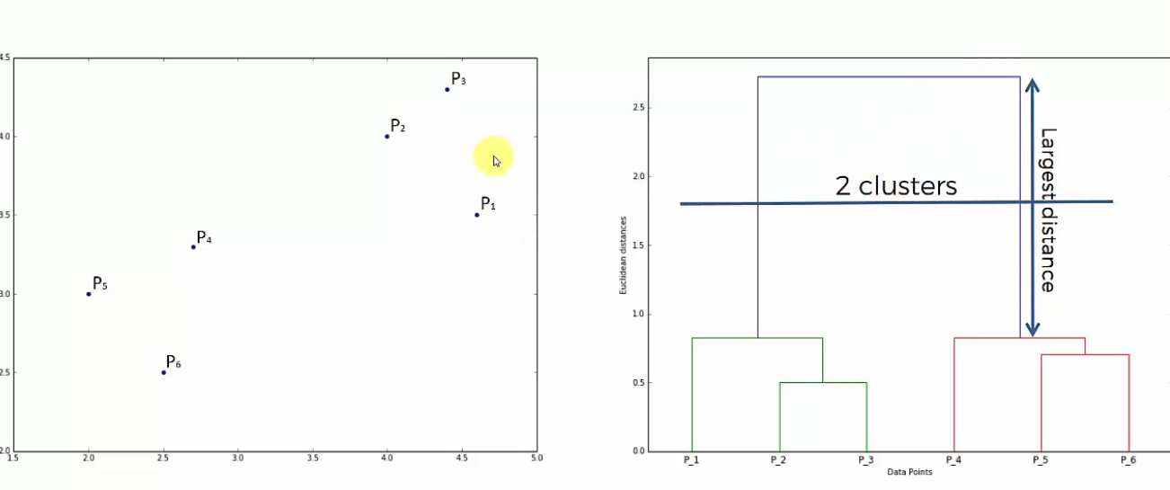

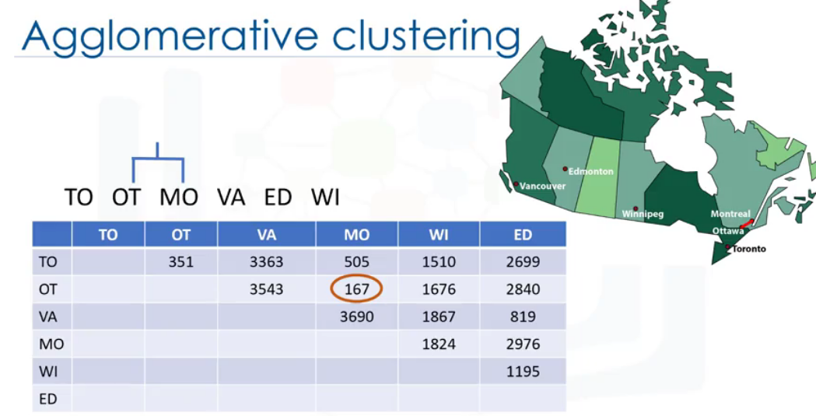

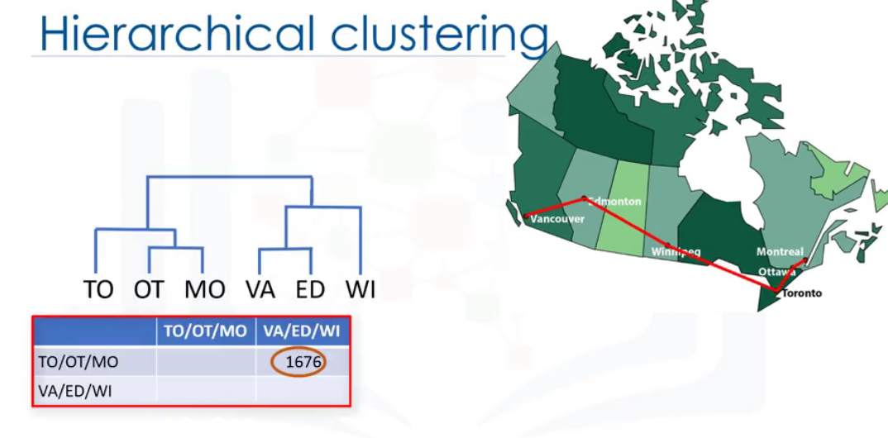

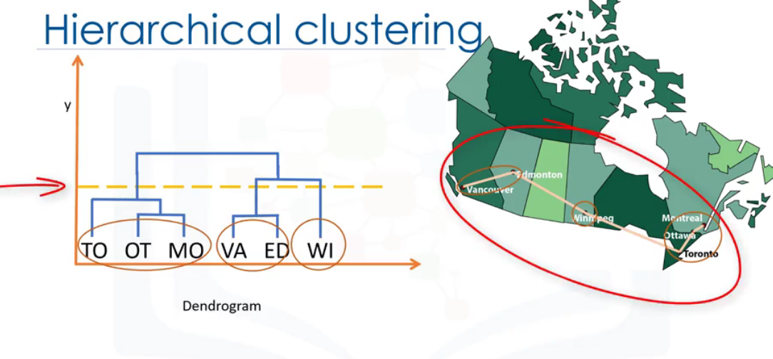

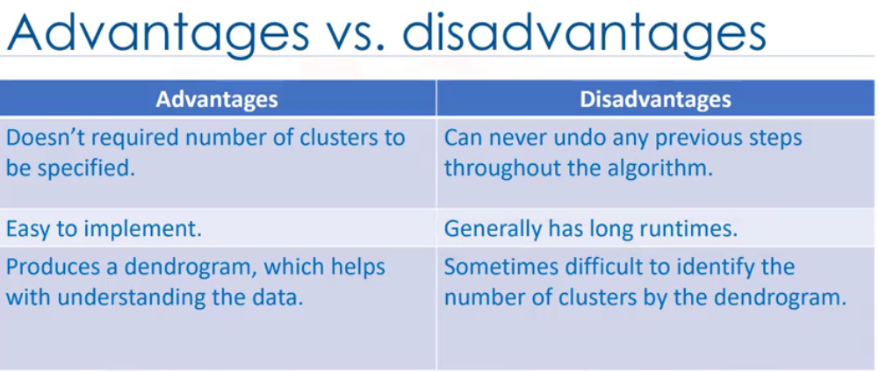

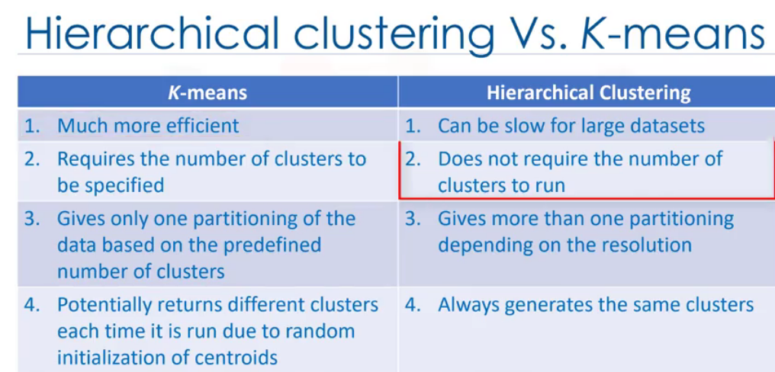

# References

Aghabozorgi, S. (n.d.). *coursera.* Retrieved from www.coursera.org: https://www.coursera.org/learn/machine-learning-with-python